**Expt. No. 10**

**Digital Logical Gates in Multisim**

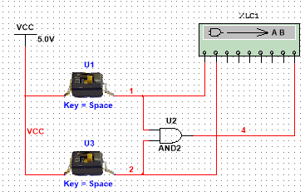

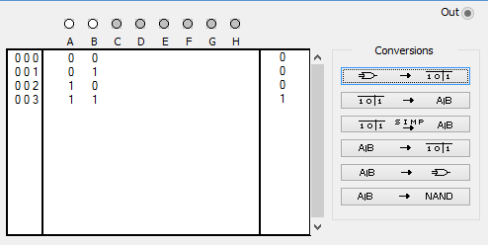

1. Verification of Output wave forms of 2-input AND Gate using piecewise linear voltage signal source:

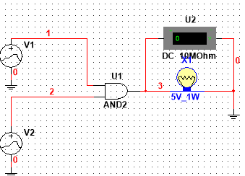

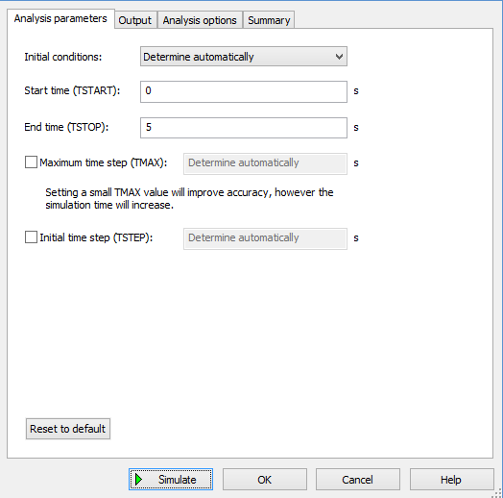 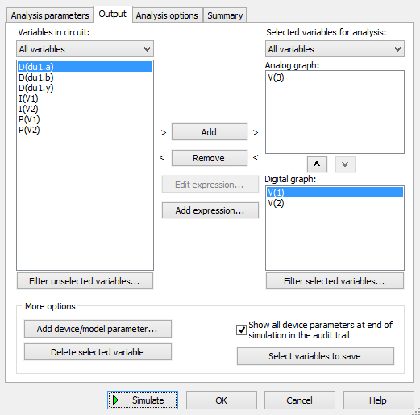

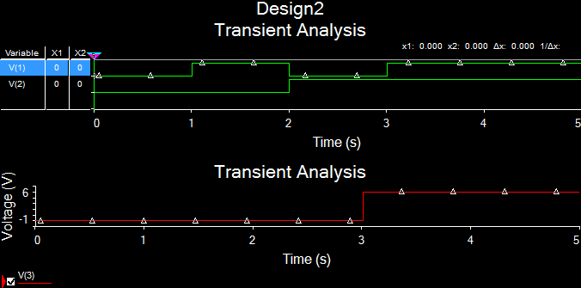

**Simulation of 3-input NAND Gate using TTL interface (74S10N):**

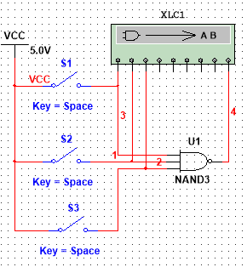

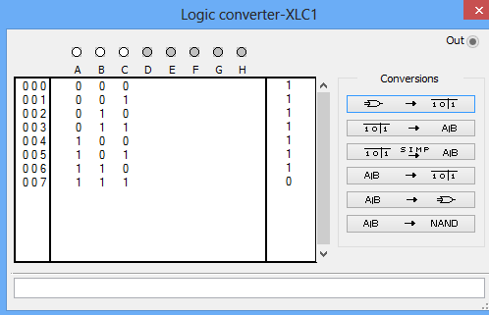

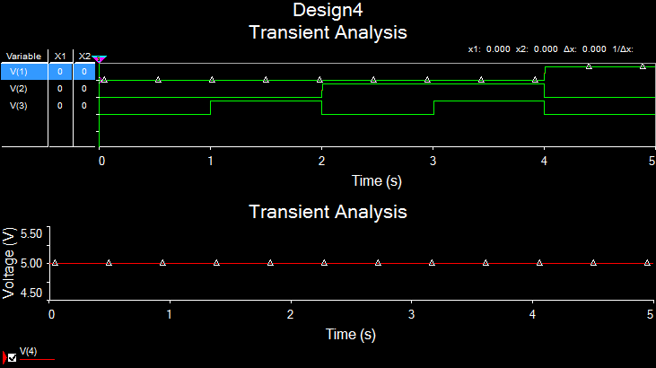

**Discussion Questions:**

1. Simulate 3-input NOR Gate & AND Gate using TTL interface (IC- 7427N, 74LS15N)

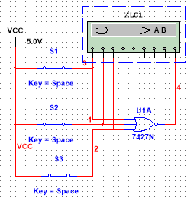 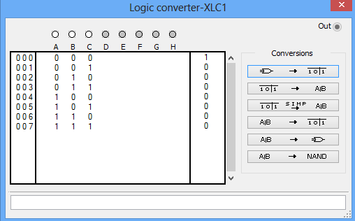

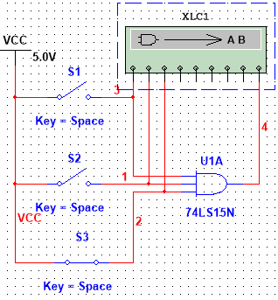 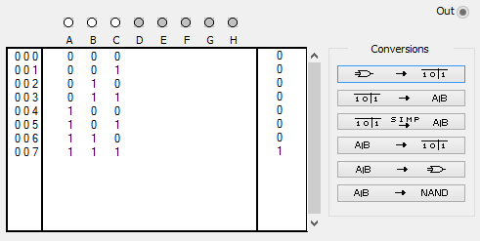

1. Why NAND & NOR gates are called universal gates? Elaborate with a simulated example.

The NAND gate and the NOR gate can be said to be universal gates since combinations of them can be used to accomplish any of the basic operations and can thus produce an inverter, an OR gate or an AND gate.

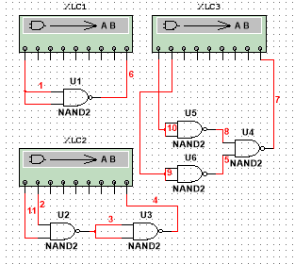

NAND as NOT:



NAND as AND:



NAND as OR:

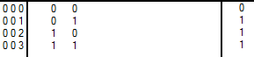

1. Realize the EXOR gate using minimum number of NAND gates.

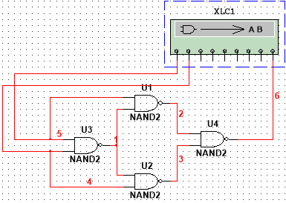

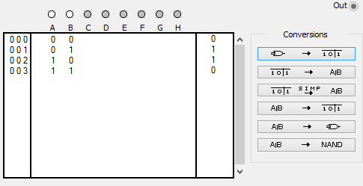

1. Compare TTL logic family with CMOS family.

|  |  |
| --- | --- |
| CMOS (complementary metal-oxide-semiconductor) | TTL (Transistor-transistor logic) |
| Uses FETs | Uses BJTs |
| Voltage Controlled Current Devices | Current controlled current Devices |
| Very high input resistance | Lower input resistance |
| Very low power consumption when not being used |  |
| Used for small Integrated Devices |  |